RESULTS

**Tribute to Hon.Raila Amolo Odinga**

Raila Amolo Odinga (born 7 January 1945), also popularly known to his supporters as Agwambo; *"The Mysterious One"*, Tinga, Baba, RAO, and Jakom; *"Chairman"* is a Kenyan politician who was Prime Minister of Kenya from 2008 to 2013.In 1992,he was elected as the **Member of the National Assembly in Lang'ata Constituency**. He served as **Minister of Energy**from 2001 to 2002, Minister of Roads, Public Works, and Housing from 2003 to 2005. He was the main **opposition candidate**in the 2007 presidential election. Following a violent post-electoral crisis, Odinga took office as **Prime Minister** in April 2008, serving as supervisor and coordinator of a national unity coalition government. He placed second in the 2013 presidential elections, garnering 5,340,546 votes, which represented 43.28% of the total votes cast

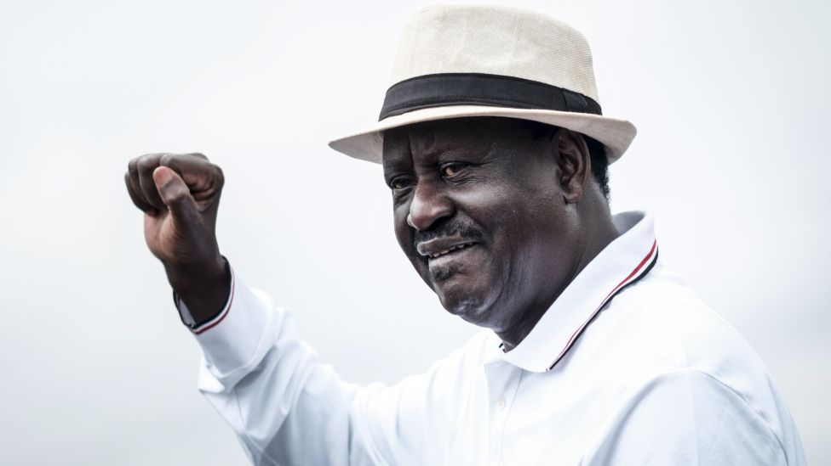

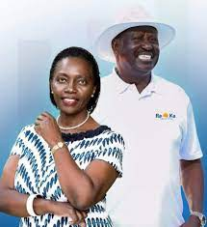

In the year 2017 GE, Raila claimed that the election was rigged and was seconded by the Supreme Court of the time. The apex court of the country ordered the IEBC to conduct the election again following the right procedured as in the constitution. Raila and his supporters celebrated the nulification of the election but disagreed with the decision of redoing the election claiming that the taxpayer money will be missued and withdrew from being a candidate but the IEBC went on doing the election without his consent making his followers to strike causing alot of damages in the country. After the retired president He.Uhuru Kenyatta saw that the country could not go on well with the chaos, he called Raila and enaged in an agreement commonly known as **Handshake**.

After handshake, the country was able to have peace and this made Uhuru to increase his friendship with Raila. They went on and decided to create the **The Building Bridges Initiatives (BBI)** to enable solve the disputes that arises during the General Election. However, a team of people led by the current president HE.Dr. William Samoei Ruto disagreed with the decision claiming that it was a deal of bringing back heredity system hence making the former president the king. The president endosed Hon. Raila Odinga as his successor following the disagreement with his deputy and formed **Azimio One Kenya Collision**where he chosed Hon. Martha Wangari Karua as his running mate.

**Early Life**

Raila Odinga was born at Maseno Church Missionary Society Hospital, in Maseno, Kisumu District, Nyanza Province on 7 January 1945 to Mary Ajuma Odinga and Jaramogi Oginga Odinga. His father served as the first Vice President of Kenya under President Jomo Kenyatta. He went to Kisumu Union Primary School, Maranda Primary and Maranda High School where he stayed until 1962. He spent the next two years at the Herder Institut, a part of the philological faculty at the University of Leipzig in East Germany. He received a scholarship that in 1965 sent him to the Technical School, Magdeburg (now a part of Otto-von-Guericke University Magdeburg) in the GDR. In 1970, he graduated with an Msc (Masters of Science) in Mechanical Engineering. While studying in East Berlin during the Cold War, as a Kenyan he was able to visit West Berlin through the Checkpoint Charlie. When visiting West Berlin, he used to smuggle goods not available in East Berlin and bring them to his friends in East Berlin.

He returned to Kenya in 1970. In 1971 he established the Standard Processing Equipment Construction & Erection Ltd (later renamed East African Spectre), a company manufacturing liquid petroleum gas cylinders. In 1974, he was appointed group standards manager of the Kenya Bureau of Standards. In 1978 he was promoted to its Deputy Director, a post he held until his 1982 detention

**Personal Life**

Baptised as a Legio Maria in his youth, Odinga later became a Born-Again Christian[37] through an Evangelical church in Nairobi.

Odinga is married to Ida Odinga (née Anyango Oyoo). They live in Karen, Nairobi and have a second home at central Farm, in Nyeri County. The couple have four children: Fidel (1973–2015), Rosemary (born 1977), Raila Jr. (born 1979) and Winnie (born 1990). Fidel was named after Fidel Castro and Winnie after Winnie Mandela. Winnie is currently studying Communication and International Area Studies as a double major student at Drexel University in Philadelphia.

In an interview with BBC News in January 2008, Odinga asserted that he was the first cousin of U.S. president Barack Obama through Obama's father. However, Barack Obama's paternal uncle denied any direct relation to Odinga, stating "Odinga's mother came from this area, so it is normal for us to talk about cousins. But he is not a blood relative."

Odinga briefly played soccer for Luo Union (now Gor Mahia) as a midfielder.

Odinga was appointed by the African Union to mediate the 2010-2011 Ivorian crisis, which involved Alassane Ouattara and Laurent Gbagbo. Raila wrote "Flame of Freedom" a 1040 paged autobiography which talks about his life from childhood. It was launched on 6 October 2013 in Kenya and subsequently in USA on 15 October 2013. He was accompanied by a section of Kenyan county governors.

* [Website](http://rao.co.ke/)
* [Facebook](https://web.facebook.com/RailaOdingaKE/?_rdr)
* [Twitter](https://twitter.com/RailaOdinga)
* [Wikipedia](https://en.wikipedia.org/wiki/Raila_Odinga)
* About
* Contact Us
* Back to Top

This Tribute page is made by **Joseph Njenga**following assignment instruction given in practice of the knowledge acquired during his Internet Application Programming Class. The Tribute information may not be factual as this is just for practice.

SOURCE CODES

<!DOCTYPE html>

<html lang="en">

<head>

  <style>

.wrapper{

  background-color: orange;

}

.rightalignimg{

  float: right;

  margin: 10px;

  align: top;

}

.footer {

  background-color:#343436;

}

  </style>

</head>

<body>

<div class="container-fluid">

  <div class="wrapper">

    <div class="jumbotron">

      <div class="row">

        <div class="col-md-4">

          <div class="page-header">

<p> </p>

<h1 class="text-center">Tribute to Hon.Raila Amolo Odinga</h1>

            <p>Raila Amolo Odinga (born 7 January 1945), also popularly known to his supporters as Agwambo; <i> "The Mysterious One"</i>, Tinga, Baba, RAO, and Jakom; <i>"Chairman"</i> is a Kenyan politician who was Prime Minister of Kenya from 2008 to 2013.In 1992,he was elected as the <strong>Member of the National Assembly in Lang'ata Constituency</strong>. He served as <strong> Minister of Energy </strong> from 2001 to 2002, Minister of Roads, Public Works, and Housing from 2003 to 2005. He was the main <strong> opposition candidate </strong> in the 2007 presidential election. Following a violent post-electoral crisis, Odinga took office as <strong>Prime Minister</strong> in April 2008, serving as supervisor and coordinator of a national unity coalition government. He placed second in the 2013 presidential elections, garnering 5,340,546 votes, which represented 43.28% of the total votes cast</p>

          </div><!--end of page header-->

          </div>

        <div class="col-md-8">

    <img src="Profile Raila.png" alt="Hon.Raila Odinga" class="img-rounded img-responsive rightalignimg" />

          </div>

 <img src="Raila Martha.jfif" width="50%" height="50%" alt="Baba & Martha" class="img-rounded img-responsive rightalignimg" />

<p>In the year 2017 GE, Raila claimed that the election was rigged and was seconded by the Supreme Court of the time. The apex court of the country ordered the IEBC to conduct the election again following the right procedured as in the constitution. Raila and his supporters celebrated the nulification of the election but disagreed with the decision of redoing the election claiming that the taxpayer money will be missued and withdrew from being a candidate but the IEBC went on doing the election without his consent making his followers to strike causing alot of damages in the country. After the retired president He.Uhuru Kenyatta saw that the country could not go on well with the chaos, he called Raila and enaged in an agreement commonly known as <strong>Handshake </strong>.</p>

<p>After handshake, the country was able to have peace and this made Uhuru to increase his friendship with Raila. They went on and decided to create the <strong> The Building Bridges Initiatives (BBI)</strong> to enable solve the disputes that arises during the General Election. However, a team of people led by the current president HE.Dr. William Samoei Ruto disagreed with the decision claiming that it was a deal of bringing back heredity system hence making the former president the king. The president endosed Hon. Raila Odinga as his successor following the disagreement with his deputy and formed <strong>Azimio One Kenya Collision </strong> where he chosed Hon. Martha Wangari Karua as his running mate.</p>

<div> </div>

      </div><!--end of jumbotron row-->

    </div><!--end of jumbotron-->

    <div id="early-life">

      </div class="row>">

      <div class="col-md-6">

    <h2>Early Life</h2>

      <p>Raila Odinga was born at Maseno Church Missionary Society Hospital, in Maseno, Kisumu District, Nyanza Province on 7 January 1945 to Mary Ajuma Odinga and Jaramogi Oginga Odinga. His father served as the first Vice President of Kenya under President Jomo Kenyatta. He went to Kisumu Union Primary School, Maranda Primary and Maranda High School where he stayed until 1962. He spent the next two years at the Herder Institut, a part of the philological faculty at the University of Leipzig in East Germany. He received a scholarship that in 1965 sent him to the Technical School, Magdeburg (now a part of Otto-von-Guericke University Magdeburg) in the GDR. In 1970, he graduated with an Msc (Masters of Science) in Mechanical Engineering. While studying in East Berlin during the Cold War, as a Kenyan he was able to visit West Berlin through the Checkpoint Charlie. When visiting West Berlin, he used to smuggle goods not available in East Berlin and bring them to his friends in East Berlin.</p>

<p>He returned to Kenya in 1970. In 1971 he established the Standard Processing Equipment Construction & Erection Ltd (later renamed East African Spectre), a company manufacturing liquid petroleum gas cylinders. In 1974, he was appointed group standards manager of the Kenya Bureau of Standards. In 1978 he was promoted to its Deputy Director, a post he held until his 1982 detention</p>

    </div><!--end of early life div-->

    <div class="col-md-6">

      <h2>Personal Life</h2>

      <p>Baptised as a Legio Maria in his youth, Odinga later became a Born-Again Christian[37] through an Evangelical church in Nairobi.</p>

<p>Odinga is married to Ida Odinga (née Anyango Oyoo). They live in Karen, Nairobi and have a second home at central Farm, in Nyeri County. The couple have four children: Fidel (1973–2015), Rosemary (born 1977), Raila Jr. (born 1979) and Winnie (born 1990). Fidel was named after Fidel Castro and Winnie after Winnie Mandela. Winnie is currently studying Communication and International Area Studies as a double major student at Drexel University in Philadelphia.<p>

<p>In an interview with BBC News in January 2008, Odinga asserted that he was the first cousin of U.S. president Barack Obama through Obama's father. However, Barack Obama's paternal uncle denied any direct relation to Odinga, stating "Odinga's mother came from this area, so it is normal for us to talk about cousins. But he is not a blood relative."</p>

      <p>Odinga briefly played soccer for Luo Union (now Gor Mahia) as a midfielder.</p>

<p>Odinga was appointed by the African Union to mediate the 2010-2011 Ivorian crisis, which involved Alassane Ouattara and Laurent Gbagbo. Raila wrote "Flame of Freedom" a 1040 paged autobiography which talks about his life from childhood. It was launched on 6 October 2013 in Kenya and subsequently in USA on 15 October 2013. He was accompanied by a section of Kenyan county governors.</p>

    </div><!--end of personal life div-->

    </div> <!--end of row 1 div-->

    </div><!--end of main early life div-->

</div>

  </div><!--end of wrapper-->

<footer class="footer">

  <div class="col-md-4">

    <ul>

      <li><a href="http://rao.co.ke/" target="_blank"><i class="fa fa-globe"></i> Website</a></li>

      <li><a href="https://web.facebook.com/RailaOdingaKE/?_rdr" target="_blank"><i class="fa fa-facebook"></i> Facebook</a></li>

      <li><a href="https://twitter.com/RailaOdinga" target="_blank"><i class="fa fa-twitter"></i> Twitter</a></li>

      <li><a href="https://en.wikipedia.org/wiki/Raila_Odinga" target="_blank"><i class="fa fa-wikipedia-w"></i> Wikipedia</a></li>

    </ul>

  </div>

  <div class="col-md-4">

    <ul>

      <li><a href="#"><i class="fa fa-user"></i> About</a></li>

      <li><a href="#"><i class="fa fa-envelope"></i> Contact Us</a></li>

      <li><a href="#"><i class="fa fa-arrow-up"></i> Back to Top</a></li>

    </ul>

  </div>

  <div class="col-md-4">

   <p>This Tribute page is made by <strong>Joseph Njenga </strong> following assignment instruction given in practice of the knowledge acquired during his Internet Application Programming Class. The Tribute information may not be factual as this is just for practice</p>

  </div>

</footer>

</div><!--end of container->

<script>

$('.rightalignimg').lightbox(options)

</script>

</body>

</html>